Fort Bonifacio Evangelical Church Management System

User Manual.

**System Overview**

Fort Bonifacio Management System is a web application that will handle their current organizational process such as membership, events reservation and church activities, with the use of this application the current process flow of the church will be efficient.

**Application**

Major functionalities of the system:

Online membership – For those people who are willing to join their organization can be easily register with the use of this. They just have to fill up those requirements listed online and have a faster process.

Online event registration – For those who are members of the church they can register an event online, and after that they only wait for the approval of the church council.

Online calendar of events – An online calendar shows every upcoming registered events of the church.

Prayer requests/concerns – This feature will received any prayer request made by the church members.

Updated news feeds of the pastors weekly messages – This feature will be a news updates which will consists of church weekly messages, upcoming large event, and etc.

Tracking system for their events, church needs, financial statements, etc. – This feature is an added feature which will be a tracking functionality for church financial statement such as tithes and offerings, donations, weekly to monthly report of the church expenses.

**Dialog Flow**

* **Copy to Local Directory**: This should be checked if files are transferred to the web server through a Windows file shared or if the installer wants to keep a local copy of the installation on their machine as a backup.
* **Path**: This should be set to the directory where Archon will be installed
* **Copy to FTP Server:** This should be checked only if files are being transferred to the web server through an FTP server.
* **Login & Password:** These are the credentials the installer should use to upload
* **FABEC Web address**: This is the URL where Archon will be accessible once copied to the web server. It should be supplied whether you are transferring files to the web via a local file share or FTP server.
* **Server Type**: This is the database server type. Currently the only database servers supported are MySQL and

**Operating Procedures**

**Login**

1. Make sure to create account 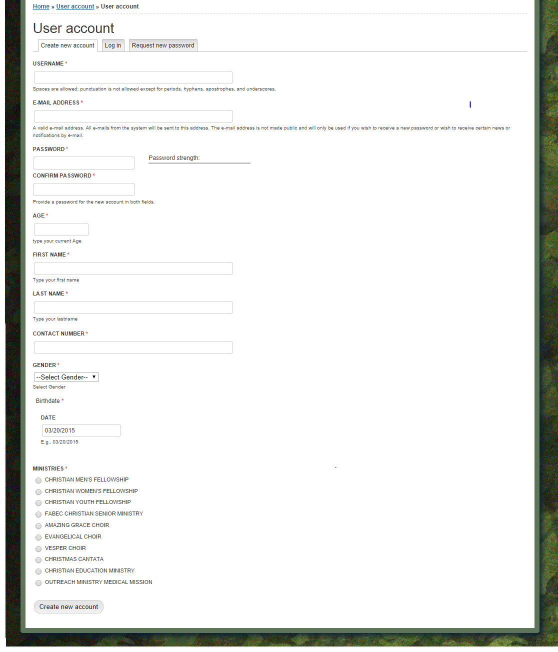
2. 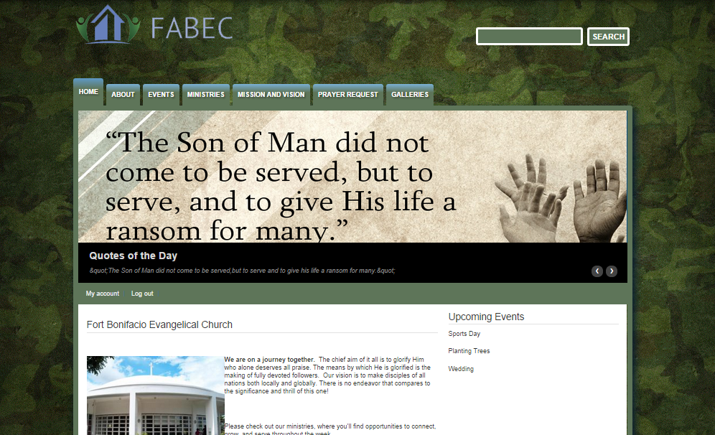Once you’ve registered the admin will approve your registration and give your password for security purposes. And then you can access the website page

**Event Calendar and Registration for Events**

1. 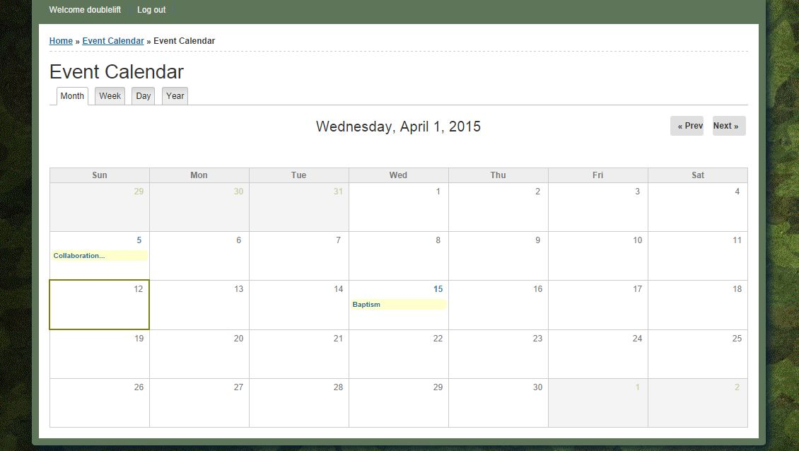In Event calendar you can access all the activities of church and once you click the activities you can register for the event for example the Baptism

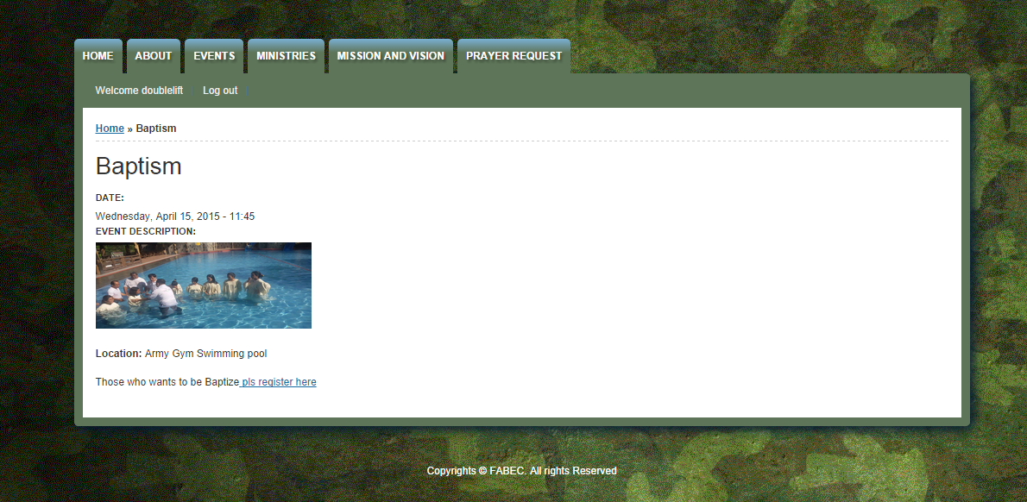

1. Click the register here and once you clicked it you can already register

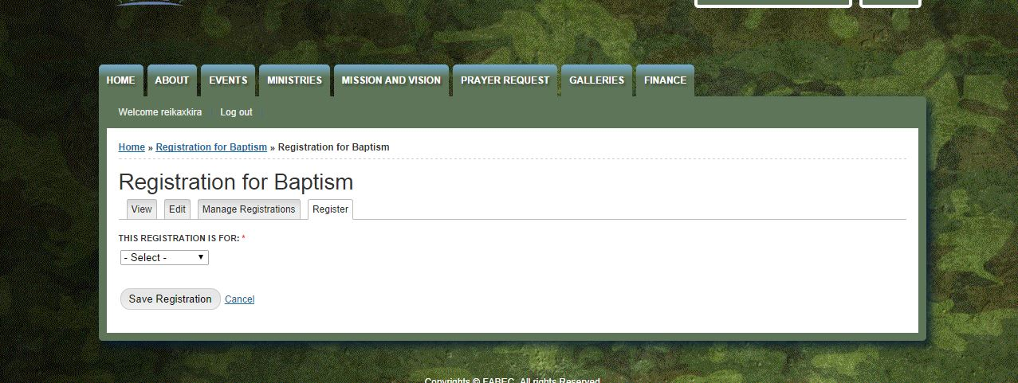

**Prayer Request**

1. Fill out the fields if you want to request a prayer

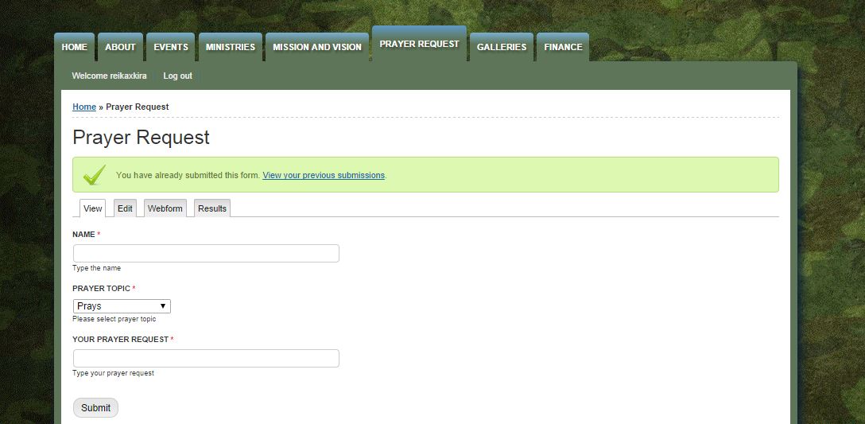

**Finance**

1. Click Content for the Admin > Add Content > Create finance after that you can upload your files in the spreadsheet or any kind files you want to upload for Finance Page

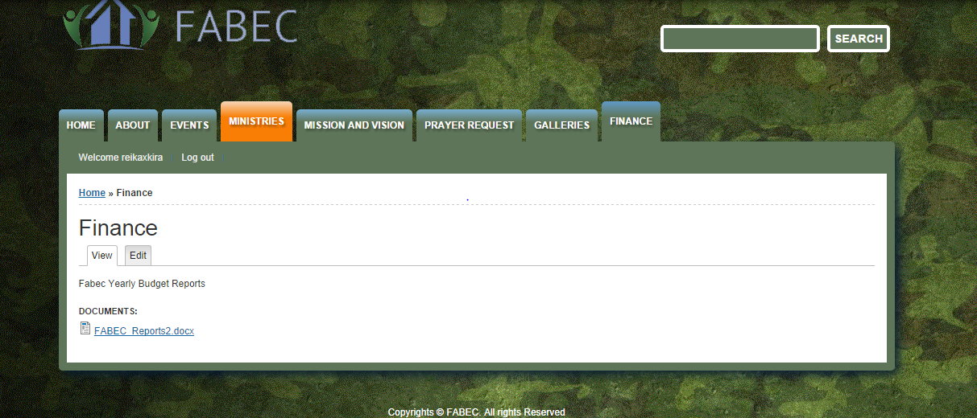

User Security and Privacy

- The system provides users with the ability to view the church events and activities related records and data archives. Higher level users are able to add, delete and modify company information. For security different restrictions for users are placed because of confidentiality of data. Only **Admins** can edit the confidential files. Users can only view, register events and request a prayer.

Sitemap

Admin

Home Page

About

Ministries

Events

Finance

Prayer Request

Upload Financial Records

FABEC Details

View the list of All Ministries

Event Calendar

Manage Registration

Simple User

Home Page

About

Prayer Request

Ministries

Events

FABEC Details

Request prayers confessions and testimonies

View the list of All Ministries

Event Calendar

Register for Events

Admin Manual:

Since we use CMS Drupal you can manage users by click the tab People

